**Project Title:** Development of the FinWise Mobile Application Prototype

**Prepared by:**

**Abstract**

FinWise is a FinTech mobile application prototype designed to address the increasing demand for seamless and secure financial management. This project showcases the development process of FinWise, from the initial requirements gathering phase to the design and implementation of an interactive prototype. By adhering to structured software engineering practices, the project ensures a balance between functionality, usability, and scalability. This document provides an in-depth analysis of the methodologies used, the challenges faced, and the lessons learned during the project.

### Project Description

FinWise is a robust FinTech solution aimed at improving personal financial management. The app offers essential features such as real-time balance inquiries, transaction history tracking, secure money transfers, and customizable notifications. Designed with the user at its core, FinWise employs cutting-edge tools like GitHub for version control and Figma for UI prototyping, ensuring a collaborative and efficient development process.

### 

### 

### 

### 

### 

### 

### 

### 

### 

### 

### 

### 

### 

### 

### Project Phases and Tasks

#### Phase 1: Requirements Engineering

**Subtasks:**

1. **Functional Requirements:**

* **Balance Inquiry:** Provide users with up-to-date account balances.
* **Transaction History:** Display categorized and filterable transaction data.
* **Money Transfer:** Allow users to transfer funds securely and efficiently.
* **User Registration/Login:** Employ two-factor authentication for added security.
* **Notification System:** Notify users of account activity, payment reminders, and promotional offers.

1. **Non-Functional Requirements:**

* **Performance:** Optimize load times to ensure a seamless experience.
* **Usability:** Incorporate a clean, intuitive design for ease of navigation.
* **Scalability:** Support increasing user loads without performance degradation.
* **Security:** Ensure end-to-end encryption for data transmission and storage.

1. **Requirement Gathering Techniques:**

* **Surveys:** Distributed online questionnaires to gather feedback from target users.
* **Interviews:** Conducted one-on-one discussions with potential users to understand their needs.
* **Focus Groups:** Organized sessions with diverse participants to refine feature requirements.
* **Use Case Diagrams and User Stories:** Visualized system interactions and identified pain points.

#### Phase 2: Version Control Setup and Collaboration

**Subtasks:**

1. **Set Up Git & GitHub:**

* Created a centralized repository to facilitate collaboration.
* Established naming conventions and commit message guidelines for clarity.

1. **Working with Branches:**

* Defined separate branches for new features, bug fixes, and testing.
* Conducted regular code reviews to maintain code quality.

1. **Collaboration on GitHub:**

* Utilized GitHub Projects to manage tasks and monitor progress.
* Recorded development milestones and documented challenges encountered.

#### Phase 3: System Design and System Modeling

**Subtasks:**

1. **System Modeling with UML:**

* **Class Diagrams:** Mapped relationships between entities like Users, Accounts, and Transactions.
* **Sequence Diagrams:** Illustrated workflows for registration, balance checks, and fund transfers.

1. **System Architecture:**

* Adopted a three-tier architecture: Presentation Layer (UI), Application Layer (logic), and Data Layer (database).
* Designed for modularity to simplify future feature integration.

#### Phase 4: User Interface (UI) Prototyping

**Subtasks:**

1. **Wireframing and Prototyping in Figma:**

* Created high-fidelity mockups of all screens:
  + **Home Screen:** Real-time balance display and quick access to key features.
  + **Transaction Screen:** Filters for date, category, and amount.
  + **Transfer Screen:** Streamlined inputs for recipient details.
  + **Profile Screen:** User information and customizable settings.

1. **UI Design Principles:**

* Adopted a consistent and visually appealing color scheme.
* Prioritized accessibility by ensuring contrast and readability.

1. **Team Collaboration:**

* Regularly sought feedback from peers and mentors to refine the design.
* Iterated on designs based on user testing results.

1. **Final Deliverables:**

* Interactive prototypes showcasing seamless navigation and functionality.
* Documented all design decisions and rationale for future reference.

### Challenges Faced

1. **Requirements Ambiguity:**

* Initial user requirements were vague and required iterative refinement through multiple feedback sessions.

1. **Version Control Conflicts:**

* Merge conflicts arose frequently during collaborative coding sessions. These were mitigated by implementing stricter branch management protocols.

1. **Technical Limitations:**

* Encountered difficulties in optimizing system performance for real-time updates, which required extensive debugging and testing.

1. **Design Iterations:**

* Balancing user feedback with technical feasibility led to multiple redesigns, impacting timelines.

1. **Time Management:**

* Aligning schedules among team members proved challenging, necessitating the use of collaborative tools to stay on track.

### Lessons Learned

1. **Importance of Clear Requirements:**

* Investing time in detailed requirement gathering upfront prevents costly revisions later.

1. **Effective Communication:**

* Regular updates and transparent discussions foster better teamwork and reduce misunderstandings.

1. **Iterative Design:**

* Embracing an iterative approach allowed for continuous improvement and refinement.

1. **Version Control Best Practices:**

* Implementing structured workflows improved code quality and reduced conflicts.

### Future Enhancements

1. **Integration with Third-Party APIs:**

* Add functionality for bill payments and investment tracking.

1. **AI-Powered Insights:**

* Use machine learning to provide personalized financial advice and spending predictions.

1. **Multilingual Support:**

* Expand accessibility by supporting multiple languages.

1. **Advanced Security Features:**

* Incorporate biometric authentication and fraud detection mechanisms.

Diagrams

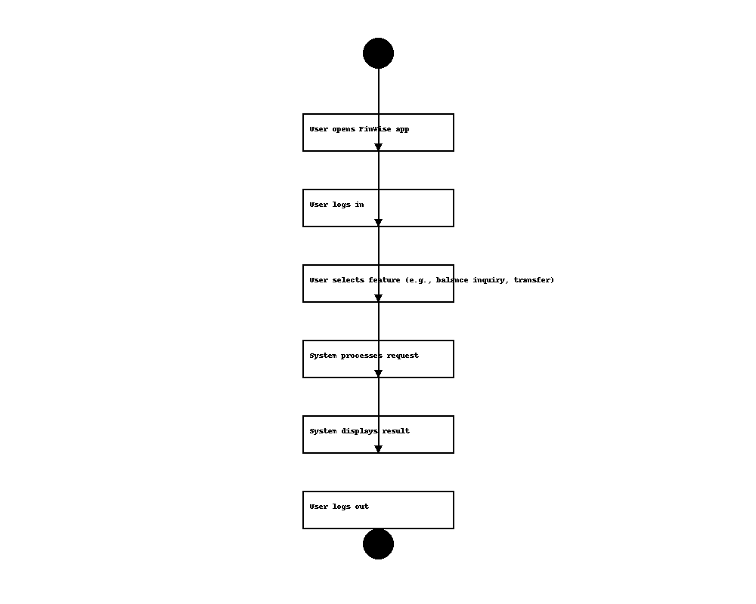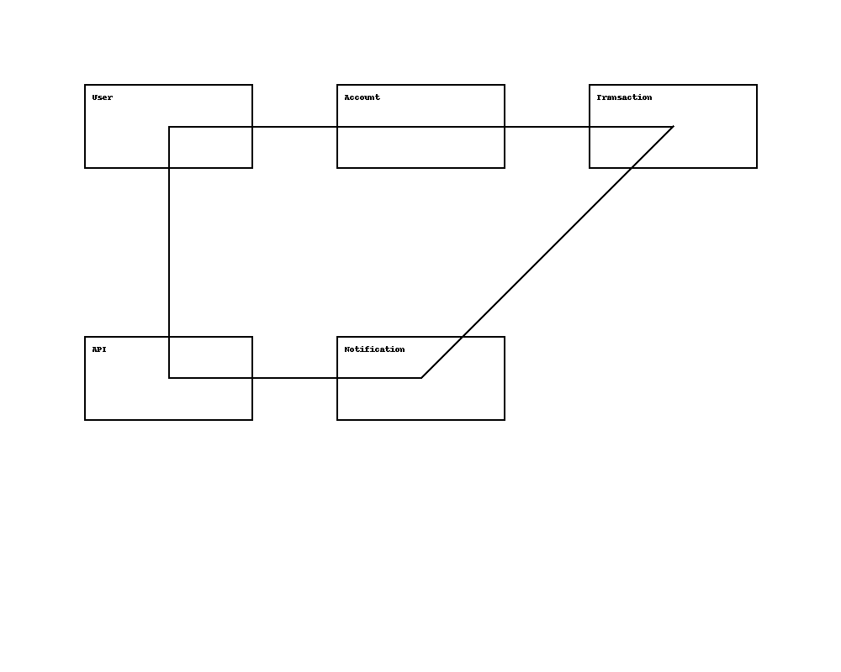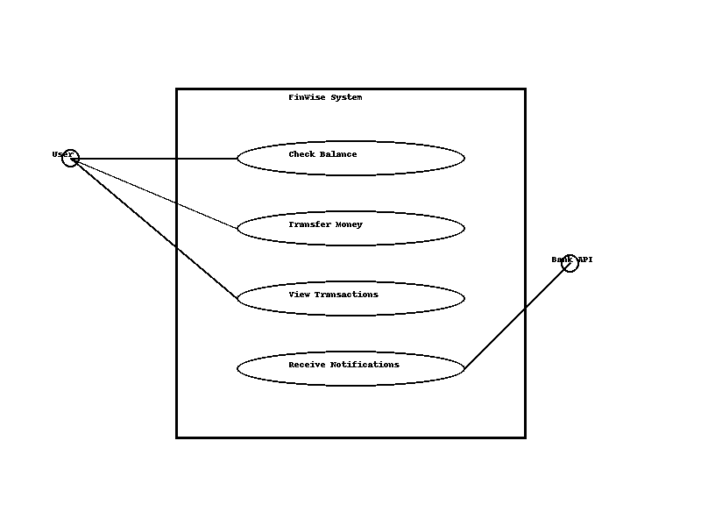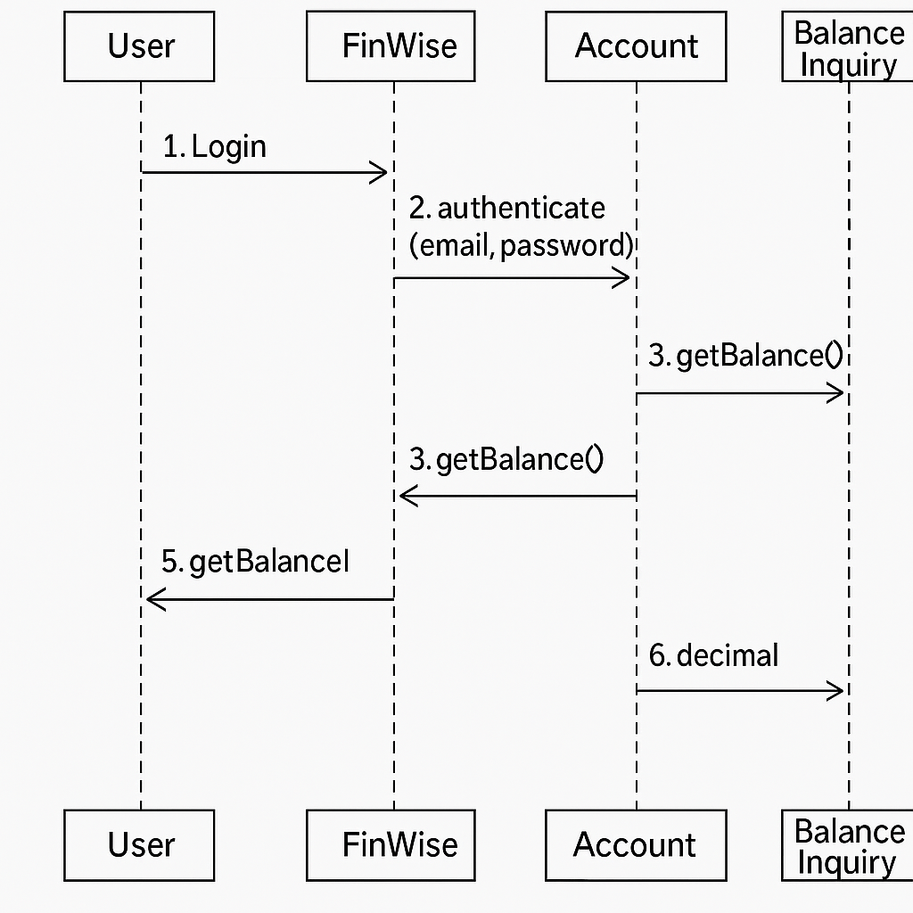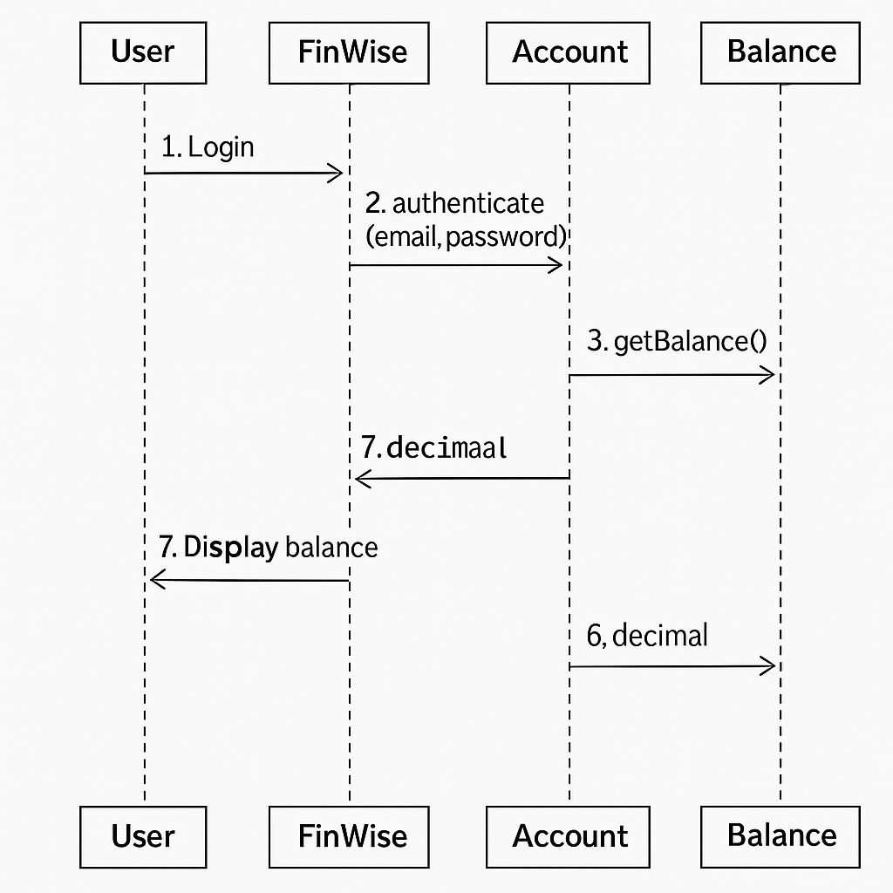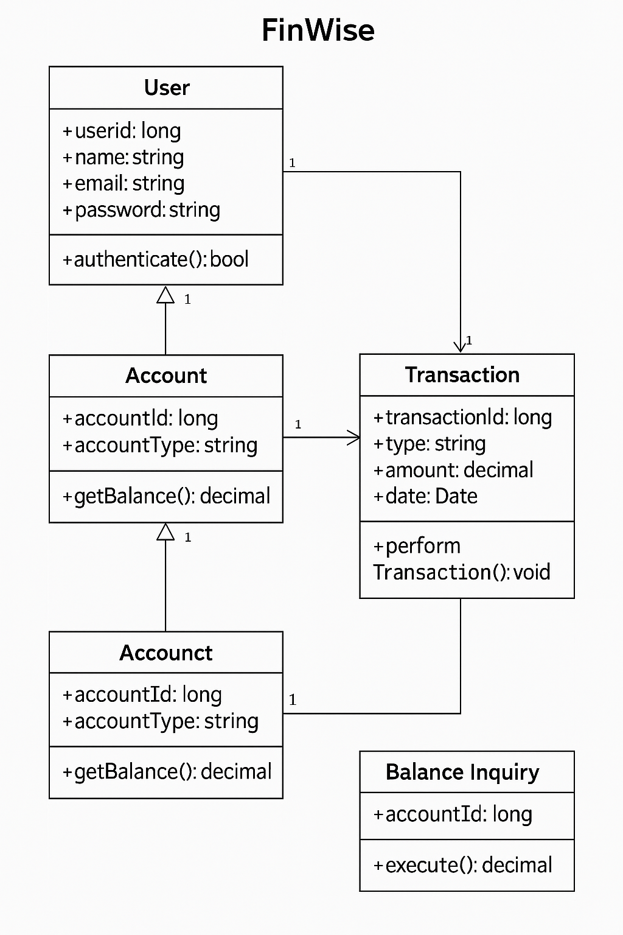

### Conclusion

The development of the FinWise mobile application prototype has been an enriching experience that demonstrated the importance of structured software engineering practices. By addressing real-world financial management challenges, FinWise offers a scalable and user-centric solution. Despite the hurdles faced, the project successfully delivered a functional prototype and laid the foundation for future enhancements. This journey underscores the value of teamwork, adaptability, and continuous learning in software development.